Title: Control of Pests and diseases with Sulphur (LIME- SULPHUR BREW)
This recipe is helpful in the control of fungal diseases and also enhancing the healthy appearance of the crop. Sulphur prohibits the growth of fungal spores. Calcium enhances the nutrient take- up by the plant. It’s therefore, important to support the application of lime Sulphur with other organic fertilizers- to ensure nutrient availability.
Ingredients
- 5ltrs water
- 1kg Sulphur
- 0.5kg builders lime Ca(OH)2
Materials: Saucepan, stirring stick, sauce of fire,
Procedure
Step 1: Mix sulphur with lime thoroughly
Step 2: Boil water to boiling point
Step 3: add lime sulphur mixture to the boiling water as you stir.
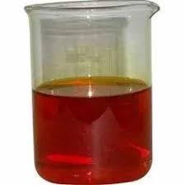
Step 4: Boil until color changes from yellow to red brown. This takes about 15 to 25 minutes
Step 5: After attaining a red brown color, let the content cool and decant off the liquid part in another container (cover the container tightly to prevent sulphur from solidifying). Store the semi-solid part in another container.

Usage
- Dilute 500ml of lime Sulphur in 20ltrs of water and spray two times a months
- For higher fungal infestation, dilute 600mls in 20ltrs of water and spray three times a month.



