Title: ORGANIC SEED COATING
Introduction
Organic Seed coating simply involves the application of natural substances around the seed coat so as to deter pests or diseases from damaging the seed. In this recipe, we apply a combination of sugars/molasses and wood ash that are very effective against pest insects and fungal attacks on seeds during storage and at planting.
How do we coat seeds organically?
Materials: sugars/molasses, wood ash, and a bucket
Procedure
Step 1: Put desired seeds in a bucket and sprinkle some molasses to moisten the seeds
Step 2: Sprinkle wood ashes as you continuously shake the seeds in the bucket. Do this until all seeds are covered with ashes.
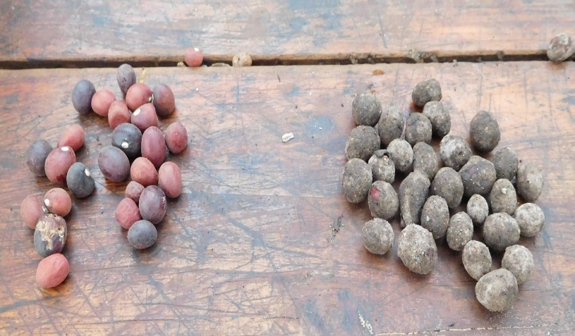
Management and usage of coated seed
The coated seeds can be planted immediately after the coating process. If to be kept/stored, dry the seed first under sunlight to prevent molding



Produced by: Wasswa Faizo Master Trainer KHEA
AFIRD Uganda, Tel: +256789688719, Email: greenisculture@gmail.com

